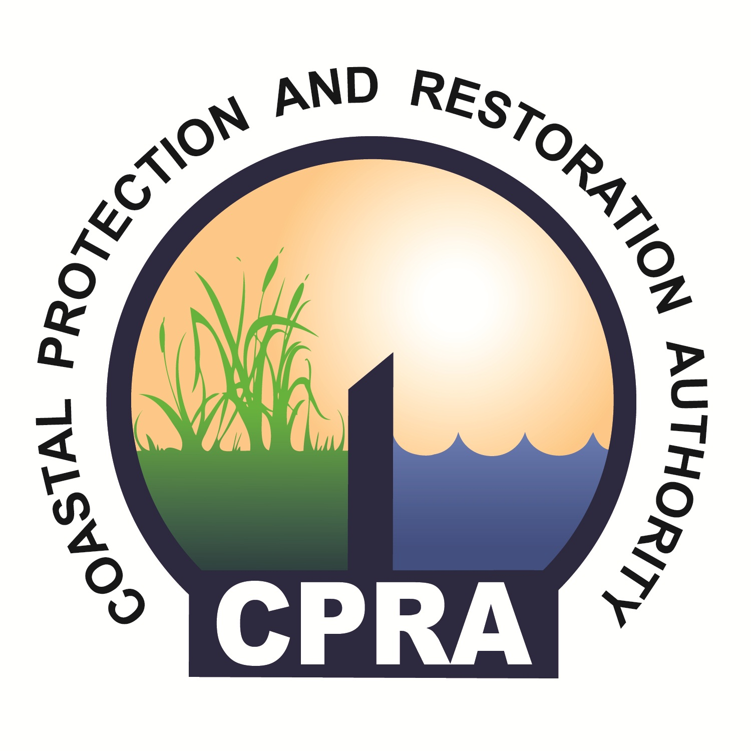

CPRA Construction
Contracting Process

CPRA Construction Process

The items below depict the construction process that is governed by Louisiana Revised Statues, Title 38. Typically, the timeframe for these activities spans from 13 to 15 weeks, depending on multiple factors including mandatory time frames driven by statute. The tasks to complete this process are listed below:

- The process begins with whether or not in-house engineering design will occur.
  - If yes, bid documents and opinion of probable construction cost are composed by CPRA Engineering.
  - If no, bid documents are submitted with opinion of probable construction cost by outside Consultant.
- Engineering reviews bid documents and opinion of probable construction cost (front end documents of bid package) for correctness.
  - If correct, the Project Manager verifies sufficient funding is in place.
    - If sufficient funding is in place, the Project Manager creates a request to advertise memo.
    - If sufficient funding is not in place, the Project Manager will seek additional or alternative funding or postpone the project.
  - If not correct, Engineering revises documents and re-submits for review.
- Once documents are approved and funding is in place, and a request to advertise memo is created.
- Project Manager approves and signs request to advertise memo.
  - If Supervisor approves and signs request to advertise memo, Project Support will review bid forms for approval.
  - If Supervisor does not approve and sign the request to advertise memo, the Project Manager has to revise the request to advertise memo.
- Once request to advertise memo is approved and signed, Project Support will review bid forms for approval.
  - If bid forms are approved, then a requisition form and annual plan section are completed.
  - If bid forms are not approved, Engineering will correct the bid forms and re-submit to Project Support; unless a Consultant constructed the bid forms – if so, the Consultant will correct the bid forms, re-submit it to the Project Manager, and the Project Manager will re-submit the forms to Project Support.
- Once bid forms are approved and requisition form and annual plan section are completed, CPRA’s Executive Office will review and approve the requisition form.
  - If requisition form is approved, Project Support will verify accounting codes; and a draft advertisement for bid will be created with available bid opening dates.
    - If accounting codes are verified, Project Support will file the original document in Project Support files.
    - If accounting codes are not verified, Project Support will revise the requisition form and re-submit for approval.
  - If requisition form is not approved, the requisition form will be revised by Project Support, and re-submitted for approval.
- Once draft advertisement is created by Project Support, the Project Manager will review the proposed bid opening dates and advertisement; and establish pre-bid conference date and location.
- Consultants or CPRA Engineering (as appropriate) will submit updated bid documents (2 digital copies) at this time.
- Project Support submits the digital copies (updated/final bid documents) to:
  - 1 copy to State printing (5 hard copies produced)
  - 1 copy for posting to CPRA website on the first date of the advertisement publications
- Concurrently with #8, the final newspaper advertisement is produced by Project Support.
- Project Support advertises the bid in the required publications.
- The Project Manager hosts a pre-bid conference and possible site visit.
- Project Support (concurrently with #11), receives written questions and requests for clarification from prospective bidders.
- The Project Manager determines the responses required based on the bidder questions – if technical answers are required, the Project Manager submits questions to the Engineer; if procedural answers are required, an addendum is created by the Project Manager.
- The Engineer (CPRA or Consultant) formulates the technical responses to the Contractor’s questions and/or Owner initiated changes in an addendum.
- The Project Manager and Engineer review question responses separately, but concurrently, for completeness and correctness.
  - If complete and correct by both, the Project Manager creates a final addendum.
  - If not complete/correct by both, changes are made, and re-submitted for review.
- Once a final addendum is compiled by the Project Manager, it is submitted to Project Support.
- Project Support posts the addendum to the CPRA website and mails to the official plan holder list.
- Contractors submit bids to Project Support.
- Project Support opens bids and reviews proposals for responsiveness.
  - If responsive, bid forms are distributed for review by Project Manager.
  - If non-responsive, Contractor’s bid proposal is disqualified.
- The Project Manager evaluates unit price bid forms and creates a recommendation to award memo in consideration of low responsive and responsible bidder.
- Concurrently (with #20), Engineering evaluates unit price bid forms and creates a recommendation to award memo in consideration of low responsive and responsible bidder.
- The Project Manager and Engineering recommendations are collected by the Project Manager.
- The Project Manager creates request to award and sends to Project Support.
- Project Support submits request to award to the Executive Director and assembles contract documents.
- Project Support submits the contract documents and notice of award to the CPRA Executive Office for signature.
- Signed documents are submitted to the Contractor who signs and returns documents with insurance and bonds to Project Support.
- Project Support verifies insurance and bonds.
  - If verified, CPRA Executive Office signs contract documents.
  - If not verified, Project Support requests re-submission from Contractor.
- Once CPRA Executive Office signs contract documents, Project Supports notifies the Project Manager.
- The Project Manager sets the notice to proceed date in conjunction with the Construction Manager and Contractor. This is then submitted to Project Support.
- Project Support sends the notice to proceed and three (3) signed contracts to the Contractor.
- The Contractor records the contract in the parish of work, and sends recordation certificate to Project Support.
- Project Support receives the recordation certificate and creates a purchase order.
- Accounting approves the purchase order.
  - If approved, Project Support files the purchase order in LaGov, and LaGov sends the filing to Project Support for confirmation.
  - If not approved, Project Support revises the purchase order, and re-submits for approval.
- Project Support prints the confirmed LaGov notice and finalizes the purchase order.
- Project Support sings the finalized purchase order and sends a copy to the Project Manager.
- The Project Manager sends the purchase order number to the Contractor. This is the final step in this process.

