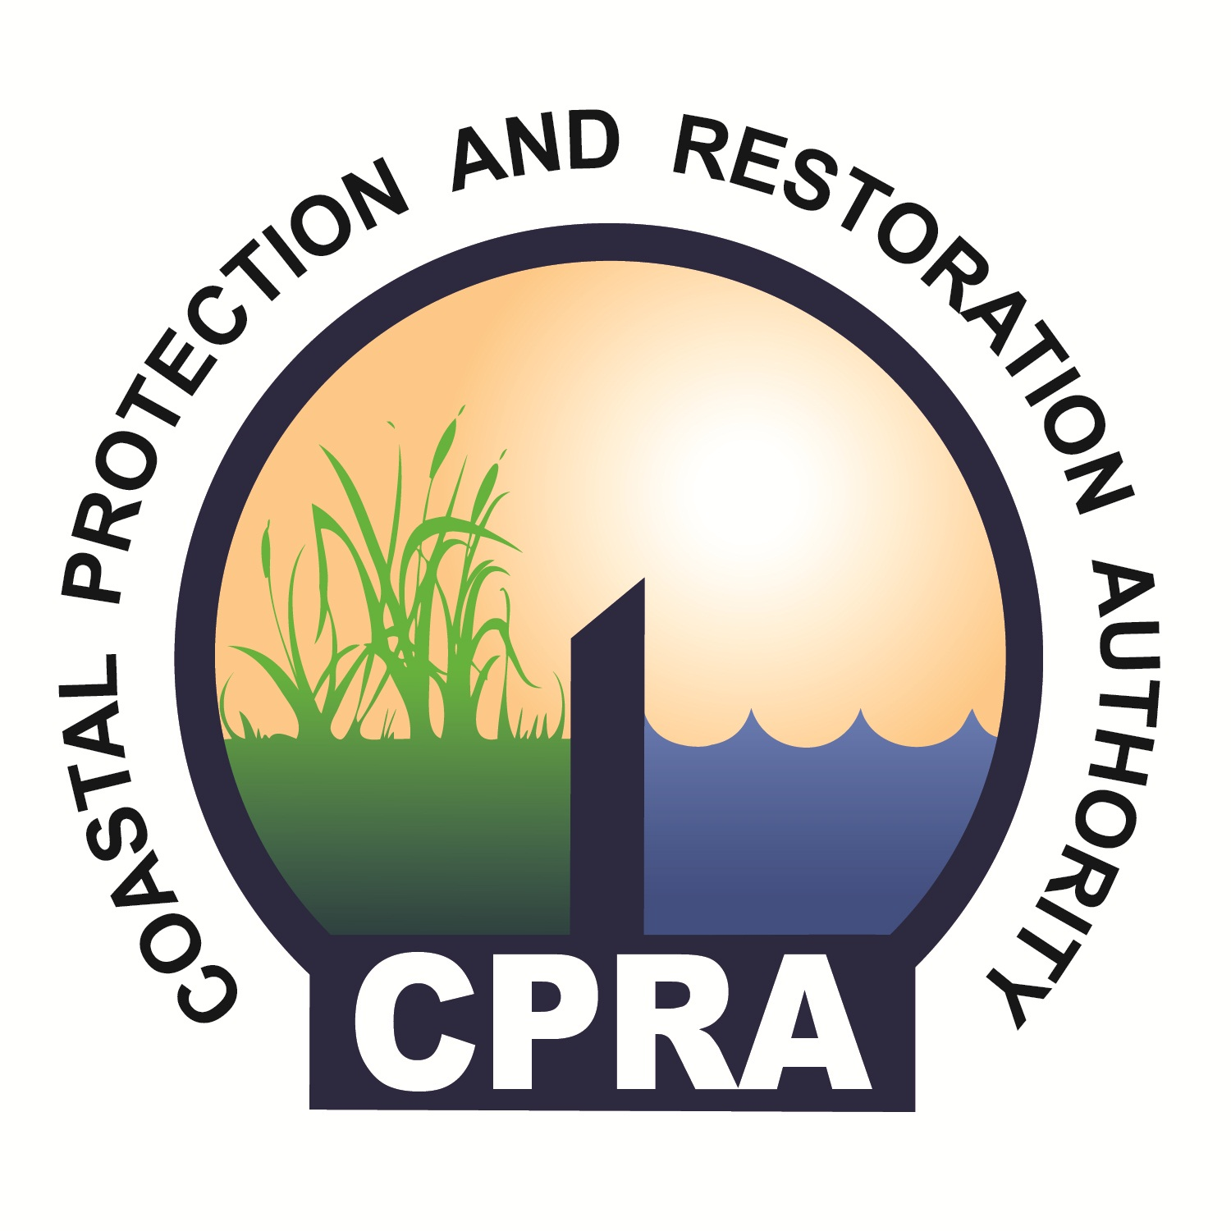

CPRA Contracting Process
Consulting Services Indefinite Delivery, Indefinite Quantity (IDIQ)

CPRA Contracting Process
Consulting Services Indefinite Delivery, Indefinite Quantity (IDIQ)

The following describes the process of establishing Consulting Services (environmental services) IDIQ contracts for the Coastal Protection and Restoration Authority. The agency utilizes environmental services contracts to perform work and implement projects/programs as outlined in the State’s Master Plans and Annual Plans. Environmental services contracts are in accordance with Title 39 of the Louisiana Revised Statutes. The contracts are retainer contracts and are used to task work on an as-needed basis. The value of contracts are based on predicted capacity needs of the agency. The contract values are placeholders, i.e., no money resides within the contracts.

The items below depict the contracting process for environmental services. Typically, the timeframe for these activities spans from 18 to 27 weeks, depending on multiple factors. The tasks to complete this process are listed below:

- The process begins when the Contract Manager submits a request(s) for request for proposal (RFP) via email/memo with the scope of services to Project Support.
- Project Support proofreads, logs and sends the RFP with the scope of services to the Chief Financial Officer.
- The Chief Financial Officer and Executive Director execute an approval process:
  - If the Chief Financial Officer approves, the package is submitted to Executive Director.
  - If the Chief Financial Officer does not approve, the project is either eliminated or revisions are needed by Project Support /responsible party. The “responsible party” is determined by Project Support.
    - If the project is eliminated, the Contract Manager is notified.
  - If the Executive Director approves, the project is reviewed by Procurement and submitted to CPRA Accounting.
  - If the Executive Director does not approve, then the project is sent back to the Chief Financial Officer. The CFO will determine if the project should be eliminated or revisions are needed by Project Support /responsible party. The “responsible party” is determined by Project Support.
- RFP approved by Chief Financial Officer and Executive Director - Project Support submits the RFP request to CPRA Accounting for funding verification.
  - CPRA Accounting approves funding and notifies Project Support.
5. Project Support submits the RFP to the Office of State Procurement for review/comment. (This step is concurrent with funding verification).
    - The Office of State Procurement reviews and notifies Project Support of approval.
    - If the Office of State Procurement does not approve, the RFP will be sent back to Project Support who will work with the Contract Manager and Chief Financial Officer to complete revisions/clarifications.
- Following the Office of State Procurement approval, and Project Support notification; Project Support will notify the Contract Manager of approval.
- Concurrently at this point:
  - Selection of the Technical Review Committee will begin by the Contract Manager.
  - Project Support will complete the advertisement according to guidelines and regulations; and post in newspapers and websites for CPRA and LaPac.
- Proposers may submit written inquires to Project Support as listed in the RFP Schedule of Events.
- Project Support receives and compiles questions from Proposers.
- Project Support, Contract Manager, and Chief Financial Officer work together to answer questions from Proposers.
- Project Support compiles answer to questions.
- Project Support posts responses to CPRA and LaPac websites.
- Proposer submits proposals to CPRA.
- Project Support performs an administrative review of proposals in accordance with the checklist.
  - Proposals are either disqualified or submitted to the Technical Committee for review.
    - Disqualified proposals:
      - Project Support composes disqualified letters.
      - Chief Financial Officer reviews the letters.
      - Project Support revises the letters if necessary.
      - Executive Director signs the letters.
      - Project Support mails the letters.
      - Disqualified Proposers receiver letters.
    - Technical Committee review proposals:
      - The Technical Committee reviews and ranks proposals per RFP requirements/guidelines, and submits rankings to the Selection Committee.
        - Either multiple or single awards will result depending on the Agency’s need.
- The Selection Committee assigns the duration(s), amount of contract(s) and number of awards if multiple awards; and assigns the duration and amount of contract if a single award.
- Selection Committee notifies the Division Chief of duration(s), amount of contract(s) and number of awards.
- Division Chief notifies the Contract Manager and Project Support of the final decision.
- Project Support drafts successful and unsuccessful letters to Proposers.
  - Chief Financial Officer reviews draft letters.
  - Project Support revises the letters if necessary.
  - Executive Director signs letters.
  - Project Support mails and/or emails successful and unsuccessful letters; and posts successful Proposer’s to CPRA website.
  - Proposers receive successful and unsuccessful letters.
18. Fourteen day protest period begins.
  - If a Proposer protests:
    - Project Support notifies the Executive Division.
    - The project is halted.
  - If no Proposer protests:
    - Project Support assembles the contract award package(s).
    - Contract award package(s) are submitted to the Chief Financial Officer for compliance review.
      - If compliant, the Executive Director signs contract award package(s).
      - If non-compliant, Project Support revises package per the Chief Financial Officer’s direction.
- Following the Executive Director’s signature, Project Support mails the contract package to the successful Proposer(s).
- Project Support requests a BA-22 form from CPRA Accounting.
- CPRA Accounting sends approved BA-22 form to Project Support.
- Concurrently, Proposer(s) receives contract package(s), sign and return contract(s).
  - If Proposer(s) signs contract, Project Support submits the signed contract package to Office of State Procurement.
  - If Proposer(s) object to contractual language, Project Support determines the correct response based on Proposer’s objection.
    - Project Support determines if legal response if needed.
    - Correct responder provides input.
    - Project Support uses input received from responder to generate a response to Proposer’s objection.
      - If response requires a change in contract language, the contract is edited.
        - Following editing, the Executive Director signs the contract with updated language.
        - The contract is resubmitted to the Proposer.
      - If response does not require a change in contract language, the contract is resubmitted to the Proposer.
- Once the Proposer(s) submits signed contract to CPRA, Project Support submits the signed contract package to Office of State Procurement for review.
  - If Office of State Procurement has no revisions, then Project Support will mail the approved contract to the Contractor.
  - If Office of State Procurement has revisions, the contract may need to be revised and follow the editing process.
- Once Project Support mails the contract, the Contract Manager is notified via email that contract is approved and recorded.
- Project Support adds contract to the active spreadsheet.
- Contract Manager begins correspondence with the Contractor. This is the final step in this process.

