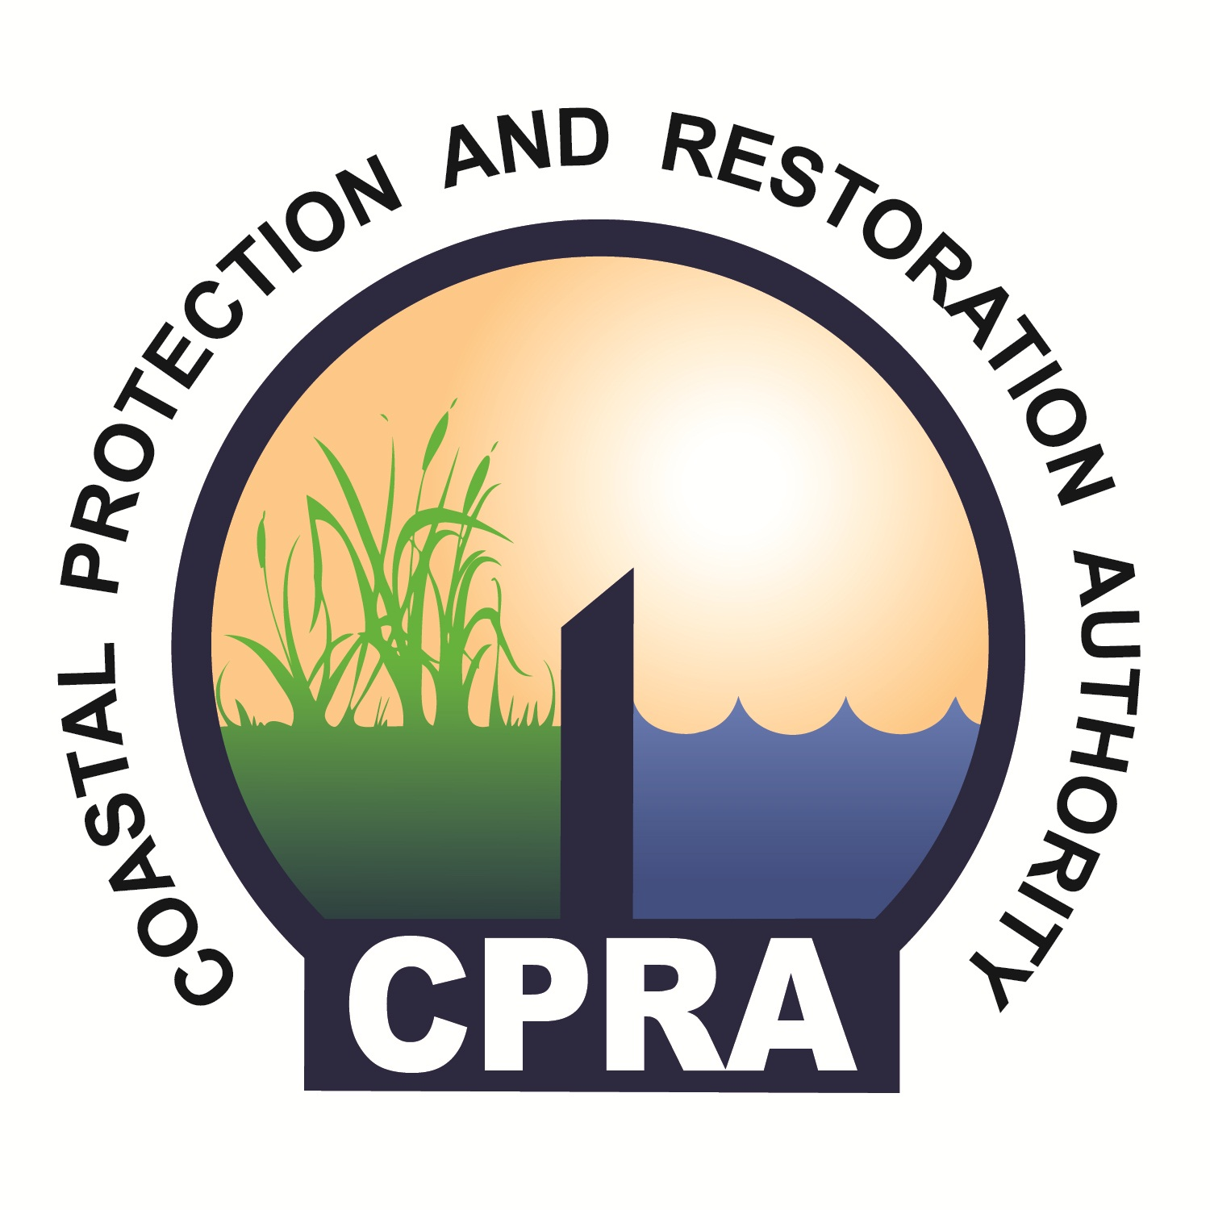
CPRA Contracting Process
Professional Services Indefinite Delivery, Indefinite Quantity (IDIQ)

CPRA Contracting Process
Professional Services Indefinite Delivery, Indefinite Quantity (IDIQ)

The following describes the process of establishing Professional Services IDIQ contracts for the agency. The agency utilizes professional service contracts to perform work and implement projects as outlined in the State’s Master and Annual Plans. These contracts are scoped and advertised individually for Engineering, Surveying and Geotechnical services. They are contracted in accordance with Title 39 of the Louisiana Revised Statutes. These IDIQ contracts are retainer contracts and are used to task work on an as-needed basis. The values of the contracts are based on predicted capacity needs of the agency. The contract values are placeholders, i.e. no money resides within the contracts. Individual task orders issued on these contracts are tied to funding sources; therefore a single contractor (contract) may be tasked with multiple projects from different funding sources.
The contracts are for a maximum of three years, with initial values ranging from $1,000,000 to $3,000,000. Contract expiration dates are staggered, with approximately one third of the contracts ending in any given calendar year. Contract expiration dates are typically (historically) August 31st of each calendar year, however this date is arbitrary. Given the current process timeline to get new contracts approved, the process (advertisement) usually begins in the mid-February to mid-March timeframe.
The items below depict the contracting process for professional services. Typically, the timeframe for these activities spans from 20 to 29 weeks, depending on multiple factors. The tasks to complete this process are listed below:

- The process begins when the Contract Manager submits a request(s) for request for proposal (RSIQ) via email/memo with scope of services to Project Support.
- Project Support proofreads, logs and sends the RSIQ with scope of services to the Chief Financial Officer.
- The Chief Financial Officer executes an approval process:
  - If the Chief Financial Officer approves, the package is submitted to Executive Director.
  - If the Chief Financial Officer does not approve, either the project is eliminated or revisions are made by Project Support /responsible party. The “responsible party” is determined by Project Support.
    - If the project is eliminated, the Contract Manager is notified.
  - If the Executive Director approves, the project is reviewed by Procurement and submitted to CPRA Accounting.
  - If the Executive Director does not approve, then the project is sent back to the Chief Financial Officer.
- Following RSIQ approval (including any necessary revisions), Project Support submits the project to CPRA Accounting for funding verification.
  - If CPRA Accounting verifies funding, Project Support is notified.
  - If CPRA Accounting does not verify funding, Project Support, the Contract Manager and the Chief Financial Officer correspond to complete revisions.
    - Following completion of revisions, and re-approval, the project is submitted back to CPRA Accounting for approval.
- Project Support notifies the Contract Manager of approval.
- Concurrently at this point:
  - Selection of the Technical Review Committee will begin by the Contract Manager.
  - Project Support will complete the advertisement according to guidelines and regulations; and post in newspapers and website for CPRA.
- Upon advertisement, Proposers may submit questions to Project Support within the specified timeframe.
- Project Support receives and compiles questions from Proposers.
- Project Support, the Contract Manager and the Chief Financial Officer work together to respond to questions from Proposers.
- Project Support compiles answer to questions.
- Project Support posts responses to CPRA website.
- Proposer submits SIQ proposals to CPRA.
- Project Support verifies minimum submission requirements are met.
  - Proposals either do not meet (receive non-responsive letter) or meet (move forward to Technical Committee review) minimum submission requirements.
    - For non-responsive proposals:
      - Project Support composes non-responsive letter(s).
      - Chief Financial Officer reviews the letter(s).
      - Project Support revises the letter(s) if necessary.
      - Executive Director signs the letter(s) following any necessary revision, and the Chief Financial Officer’s approval.
      - Project Support mails the letter(s).
      - Non-responsive Proposer(s) receiver letter.
    - For Technical Committee review proposals:
      - The Technical Committee reviews and ranks proposals per RSIQ requirements/guidelines, and submits rankings to the Selection Committee.
        - Either multiple or single awards will result depending on the Agency’s need.
- The Selection Committee reviews and notifies Project Support and the Contract Manager of award(s).
- Project Support drafts successful and unsuccessful letters to Proposer(s).
- Chief Financial Officer reviews draft letters.
  - If needed, Project Support completes any revisions to letters.
  - If not needed, letters are forwarded to the Executive Director for signature.
- Executive Director signs letters.
- Project Support mails and/or emails successful and unsuccessful letters; and posts successful Proper’s to CPRA website.
- Concurrently, Proposers receive successful and unsuccessful letters.
- The Contract Manager emails success Proposer(s) the standardized blank rate schedule.
- Proposer(s) complete the standardized rate schedule.
- The Contract Manager receives all Proposer(s) rate schedules and calculates maximum rate schedule.
- The Contract Manager modifies the Proposer’s rate schedule (if needed).
- The Proposer(s) accepts the modified rate schedule.
  - If yes, the Contract Manager approves the final rate schedule.
  - If no, the rate schedule is modified and resubmitted for acceptance to the Proposer.
- The Contract Manager completes the final rate schedule, scope and sub-contractor list for each contract.
- Project Support assembles the contract packages.
- The Chief Financial Officer completes a compliance review on the contract package(s).
  - If the package(s) is found to be in compliance, it is forwarded to the Executive Director for signature.
  - If it is found to be non-compliant, Project Support edits the package(s) and resubmits for approval.
- Following successful compliance review, the Executive Director signs contract package(s).
- Following the Executive Director’s signature, Project Support mails the contract package to the successful Proposer(s).
- Project Support requests form BA-22 from CPRA Accounting.
- CPRA Accounting sends approved form BA-22 to Project Support.
- Concurrently, Proposer(s) receives contract package(s), sign and return contract.
- Once the Proposer(s) submits signed contract to CPRA, Project Support submits the signed contract package to the Office of State Procurement for review.
  - If the Office of State Procurement has no revisions, Project Support will mail the approved contract to the Contractor(s).
  - If the Office of State Procurement has revisions, the contract may need to go back to drafting, and follow the editing process.
- Once Project Support mails the contract, the Contract Manager is notified via email that contract is approved and recorded.
- Project Support adds contract to the active spreadsheet. This is the final step in this process.

